**Assignment 7**

Based on the readings, lecture slides, and materials in the Module 6, answer the below questions and submit via blackboard in a .docx or .pdf format.

To perform this assignment, you will need to use Valentina Studio that we have been using this semester to build a form that will allow users to enter information into our Sakila database without having to utilize and SQL. For this assignment, we are only implementing single table forms.

This assignment will take some time as there are several steps to follow, so please start early to allow for time to complete the activity.

**To develop a form, we must begin by creating a new “Project” within the database that will allow for us to create the form. The following steps illustrate how to create the Project.**

1. First, go to Project>New Project> Local as seen below 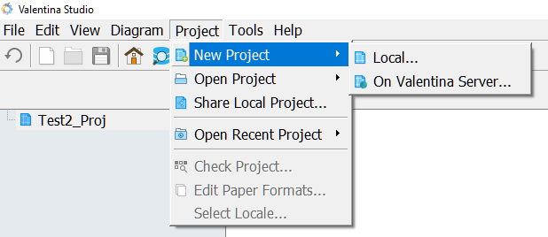
2. Next, you’ll be asked to determine the name and location of the project. For this project, let’s name it Sakila Form, as seen here. 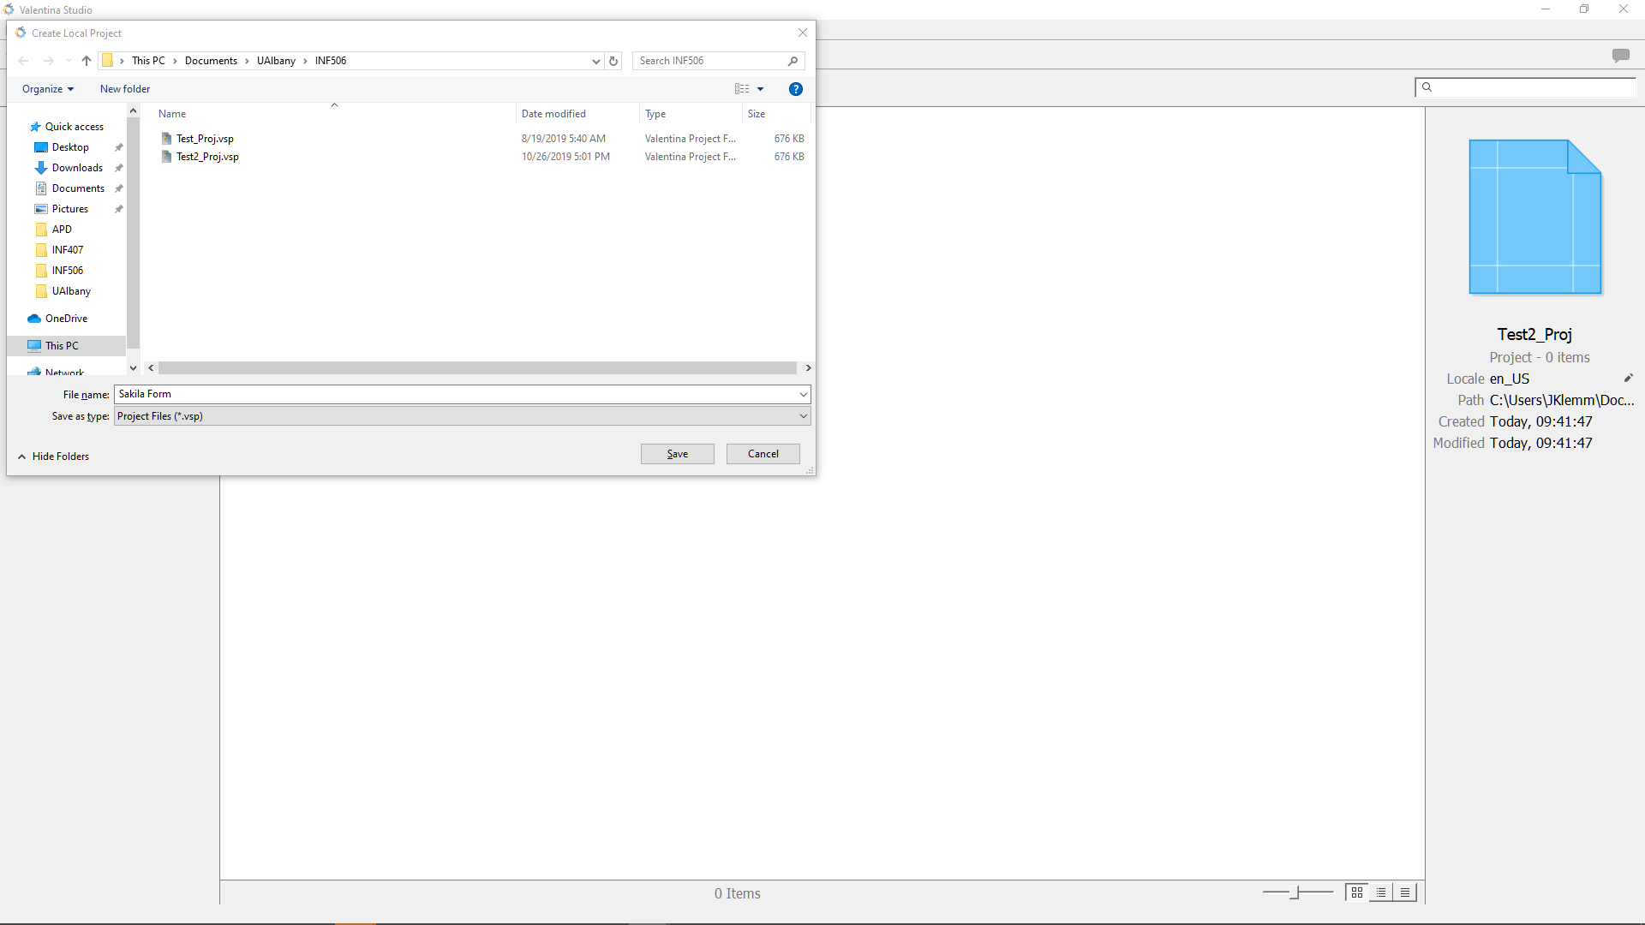
3. Next, on the Project screen, choose: Create > Datasource as seen below: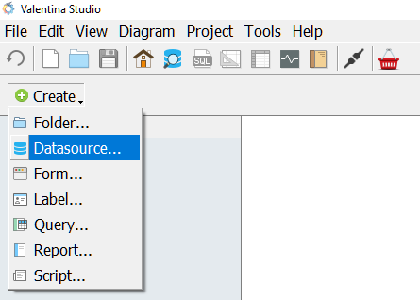
4. Here Browse to your Sakila Database, and click OK. 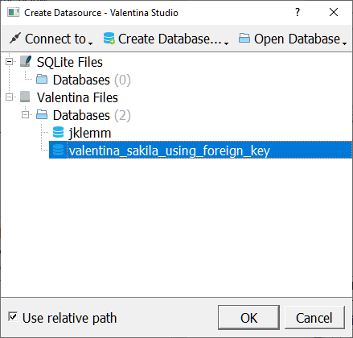
5. You will now see the Data Source on your project.

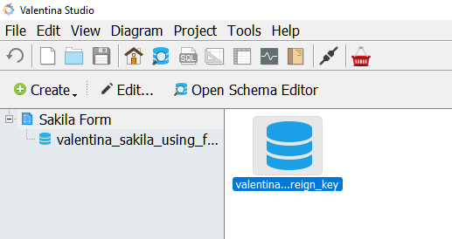

1. Now go to Create > Form 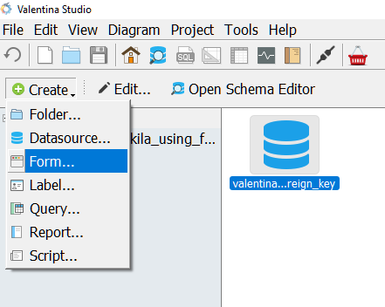
2. Here, name the Form “FilmForm” as seen below: 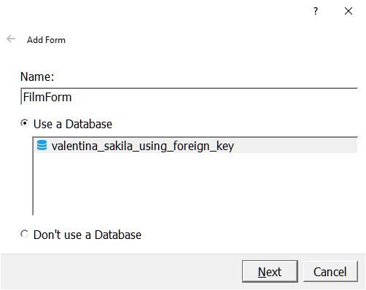
3. Now, we will choose what table to use, which will be Film in our case: 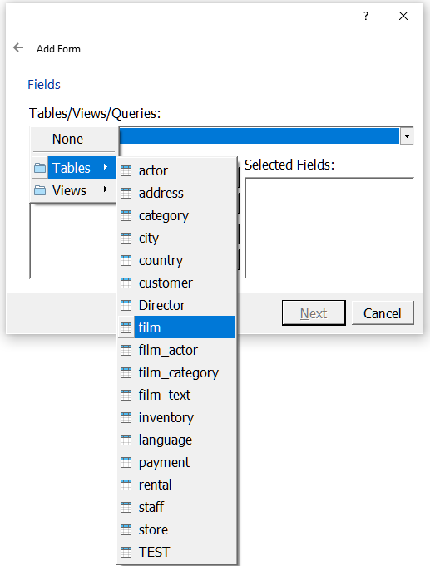
4. The list of available fields to bring to our form will appear on the left, we are going to select all of them for this assignment. To do so, click the “>>” button on this form. Then click Next.
5. For this Assignment, we will be choosing a columnar layout, with Edit functionality, as seen on the screen below, then click Finish: 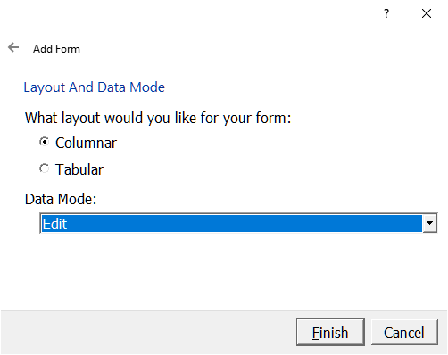
6. You will now see the form that we can modify and use for this assignment, click “Execute” to launch the form: 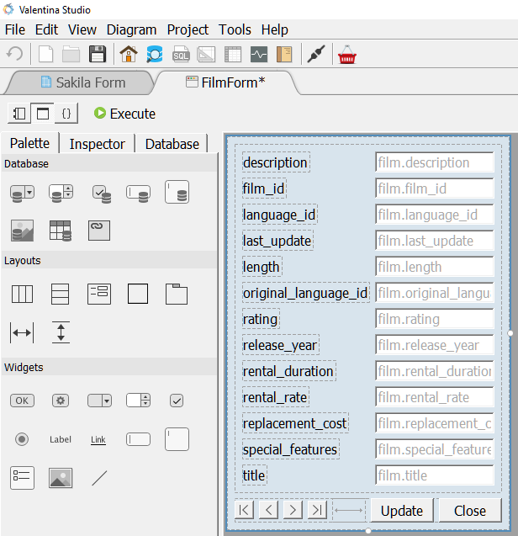

**Guided Date Updates: We will be modifying the data in the Film table via our Form for the following five tasks. We will be using the left and right arrows: < > to browse through the films to make our adjustments. Note there is nothing to submit for this portion of the assignment.**

1. For Film_ID 1, Rename the Title of the Film to INF 506 (if this gives an error, disregard it)
2. For Film_ID 2, Change the Rating to R
3. For Film_ID 3, Change the Rental_Rate to 1.00
4. For Film_ID 4, set the Original_Language_ID to 2
5. For Film_ID 10, delete all text in the special features.

**Submission:**

1. For each of the 5 previous changes, submit a query that returns *only* the Film_ID and the column that was modified in each step. This should be submitted as 5 individual queries and 5 individual results.

**Created Form -**

**Answers –**

1. SELECT Film_ID, title

FROM film

Where Film_ID = '1';

1. SELECT Film_ID, rating

FROM film

Where Film_ID = '2';

1. SELECT Film_ID, rental_rate

FROM film

Where Film_ID = '3';

1. SELECT Film_ID, original_language_id

FROM film

Where Film_ID = '4';

1. SELECT Film_ID, original_language_id

FROM film

Where Film_ID = '10';

